**SMALL-SIZE ADJUSTABLE LOOP MICROWAVE FOR USE WITH MOBILE PHONES**

*1 P.Akhila , 2J. Akshitha ,3K.Neha, 4MR.K. Subash*

# *1,2,3bachelor Degree, Cse,* *Jayamukhi Institute Of Technological Sciences Narsampet, Warangal.*

4*Mr. K Subash, Assistant Professor, bachelor Degree, Cse, Jayamukhi Institute Of Technological Sciences Narsampet, Warangal.*

**ABSTRACT:**

A tiny 55 x 5 x 3 mm3 reconfigurable loop antenna is suggested for use in mobile phone applications. The suggested loop antenna creates a fourth 2- mode in addition to the classic three loop antenna modes of 0.5-, 1-, and 1.5-. Therefore, the reconfigurable approach is used by adding an RF switch to the end of the suggested antenna to increase bandwidth at the low band, allowing for the coverage of multiple operating bands with such a small antenna volume. The suggested antenna may cover the GSM850/900, DCS1800, PCS1900, UMTS2100, and LTE2300/2500 bands with low specific absorption rate and high efficiency by integrating the four operating modes of the RF switch.

**INTRODUCTION:**

The most difficult task at the time is to create a wideband antenna with a very small size/volume because to the rising demand for ultra-thin smart phones. A single passive and tiny antenna often struggles to support multiple bands and wide bandwidth sufficient to support all the necessary WAN bands for worldwide applications since the ultrathin smart phone offers extremely limited available places for creating the requisite antenna. One of the workable techniques to reduce antenna size is the reconfigurable or active tunable antenna [1]–[8]. PIN diodes [1] through [4], digitally programmable capacitors [5], or RF-MEMS (micro-electro mechanical systems) switches [6] through [8] can all be used to provide frequency configurability. The kind of antenna, tuning range, harmonic side effect, RF component loss, and other factors affect which RF tunable technology should be used.

In addition to PIFAs (planar inverted F antennas), IFAs (inverted F antennas), and monopole antennas, loop antennas might potentially be used in mobile phone applications due to their advantageous multi-resonant modes. According to reports in [9] and [10], a 3-D type folded loop antenna may produce up to three resonant modes within the relevant LTE bands, namely the 0.5-, 1-, and 1.5-modes.

Recent research has examined loop antennas with a higher 2- resonant mode [11]–[13].

According to [12], the distance between the feed and shorting point of the loop antenna generates the higher 2- resonant mode. The antenna size of [11]-[13], however, is very big, measuring 50135 mm3, 6085 mm3, and 75105 mm3, respectively. Consequently, they are inappropriate for extremely thin and narrow frames. apps for smartphones This work proposes a tiny internal loop antenna (55 5 3 mm3) with multimode operation (up to four resonant modes) and frequency agility. In this work, four operating states are introduced using a single-pole, fourth-row RF switch (RF-1604) so that the suggested antenna can function at the appropriate bands. Table 1 compares the proposed antenna to those loop antennas previously described in order to better highlight the benefits of the proposed antenna. With this design approach, the occupied volume may be considerably decreased as compared to the reference ones. The findings demonstrate the suggested antenna's ability to provide two broad frequency bands, with the low band and high band being 780–990 MHz (210–MHz or 23.7%) and 1670–2740 MHz (1070 MHz), respectively.

Thus, the GSM850/900, DCS1800, PCS1900, UMTS2100, and LTE2300/2500 bands may be covered by both low and high bands.

The observed antenna efficiency of the low and high bands can also reach values of 59% and 82%, respectively.

The specific absorption rate (SAR) is also examined in order to further our understanding of how antenna radiation affects human head at transmit mode.

There is a 5 56 mm2 no-ground zone visible on the left side of this protruded ground as a result. The protruded ground in this instance can be utilised to arrange electrical parts like a metal USB connection.

The suggested antenna is supported above the system circuit board using a 3 mm thick ABS (Acrylonitrile Butadiene Styrene) substrate antenna carrier (r = 3, tan = 0.01), with a gap of 1 mm established between the antenna carrier and its rose ground plane. The radiating dipole element is situated in the no-ground zone and has a total volume of only 55 x 5 x 3 mm3 (made on ABS).

The construction of the RF switch and the suggested antenna's precise planar dimensions are shown in Fig. 1(b). Three branches make up the idea for the antenna: branch #1, a folded loop antenna along sections A–B–C–D–F–G–H–I–JK; branch #2, a section J–L–M; and branch #3, a section B–N.

Four resonant modes for the relevant bands can be excited by the folded loop section (branch #1), and a few methods are employed to enhance the performance of the suggested antenna. In this instance, branches #2 and #3 are made to accomplish the high band operation bandwidth. . A series 5 nH inductor is loaded at the feed point as a matching component to ensure appropriate resistance matching. The terminal end (point K) of branch #1 is connected to an SP4T (single-pole-four throw) RF switch (model RF-1604) for frequency agility in order to span the low band from 780 to 980 MHz. The four RF ports (RF1 to RF4) are connected to four lumped components from the enlarged schematic of this RF switch in Fig. 1(b). The two bias voltages (V1 and V2) control the RF switch states.

**RELETED DATA:**

Charm is a flexible framework for quickly prototyping cryptographic systems, which we discuss. Charm has a variety of features that specifically facilitate the creation of novel protocols, such as infrastructure for creating interactive protocols and support for the modular composition of cryptographic building pieces. Additionally, our framework offers a number of specialised tools for the interoperability of various cryptosystems. Using Charm, we constructed more than 40 cryptographic algorithms, some of which were novel and, to our knowledge, had never been developed in practise. This article presents our modular design with a benchmarking module included to evaluate the performance of Charm primitives against current C implementations.

We demonstrate that many times our solutions reduce code size by an order of magnitude without causing a tolerable performance effect. The Charm framework is moreover freely accessible to the research community, and up to this point, we have amassed a sizable, active user base.

**EXIXTING SYSTEM:**

Jues and Kaliski [13]. In PoR, one can combine error-correcting code with spot-checking of data blocks to ensure the data's integrity. But this technique only supports a limited number of verification operations. At the same time, Atniese et al. proposed provable data possession (PDP) based RSA-homomorphic authenticators, which can support both unlimited number of challenges and public auditing [3].

Subsequently, many works focused on the improvement of communication efficiency [4], [7], [11], [20]. Some other researches considered the dynamic update of PDP schemes [12], [22], [26], [28]. To support data dynamics, kinds of authenticated data structures are widely introduced into the public auditing schemes. For example, in 2011, Wang et al. presented the Merkle-hash-tree-based public auditing for dynamic data [26]. Later, Zhu et al. proposed a new data structure, called index hash table, to achieve data dynamics [34]. In 2017, Tian et al. further suggested a two-dimensional data structure, named dynamic hash table, to achieve both public auditing and dynamic data updating [22]. At the same year, Shen et al. proposed another novel structure, which includes a doubly linked info table and a location array,

to achieve dynamic data [21].

However, few of them can be directly extended to achieve efficient and secure verification for data storage in the fog-to-cloud based IoT scenarios, although there are fruitful schemes suggested in the traditional cloud storage. The two main reasons are as follows. First, in fog-to-cloud case, the data are usually generated by various IoT devices, instead of the data owners themselves. Second, some new entities, like fog nodes, are introduced and also play important roles for processing and transmission in fog-to-cloud scenario. But in the traditional cloud storage, they are never considered.

Therefore, in the recent works, Tian *et al.*, [23] and Kashif and Mohammed [18] respectively filled this gap in the public auditing setting based on different techniques. Nevertheless, the more efficient private key auditing schemes are not considered in both papers.

**PROPOSED SYSTEM:**

In the proposed system, the system tries to take the step to this direction. More specifically, we propose a new auditing system based on private authentication techniques: message authentication code (MAC) [14] and homomorphic MAC (HMAC) [2], [8]_[10] schemes, both of which are important primitives in cryptography. The MAC technique is used in the transmission process between mobile sinks and fog nodes while the HMAC scheme is used to verify the integrity of data blocks stored in CSP. Since a common private key is needed for the parties in MAC or HMAC when generating or verifying the tags, this model is not suitable to introduce TPA into it. Moreover, we give a concrete instantiation of the system by instantiating the hash-based MAC scheme in [14] and the efficient HMAC scheme designed by Agrawal and Boneh in [2].

**RESULT:**

****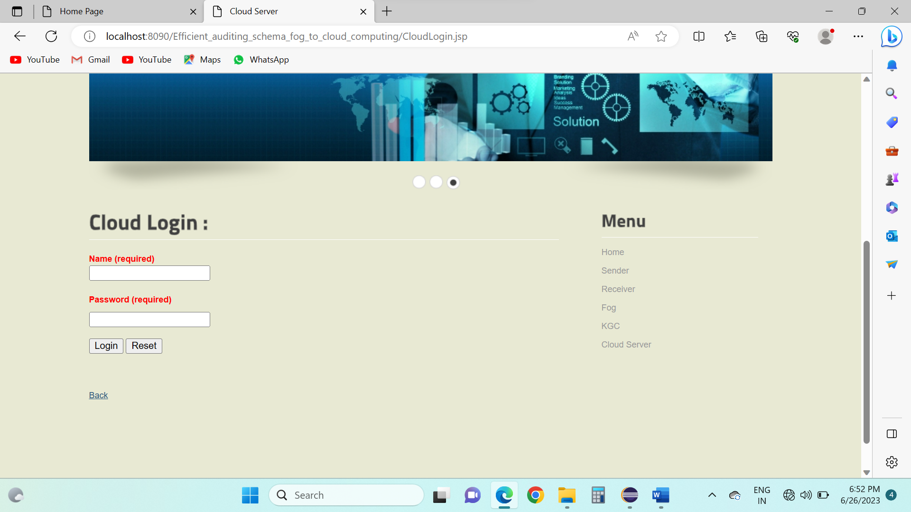

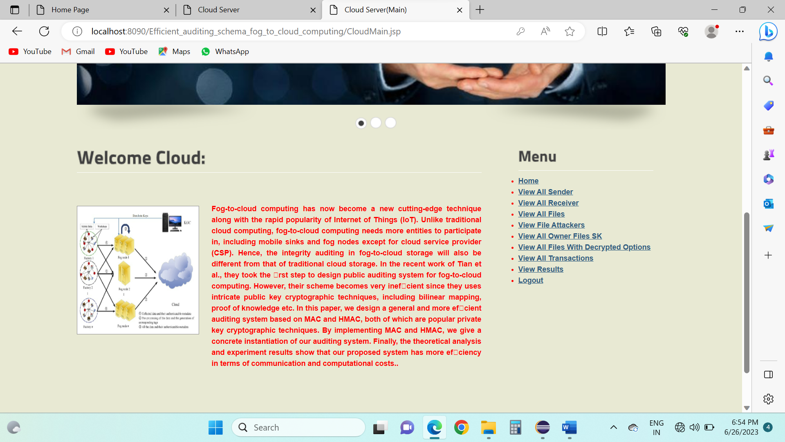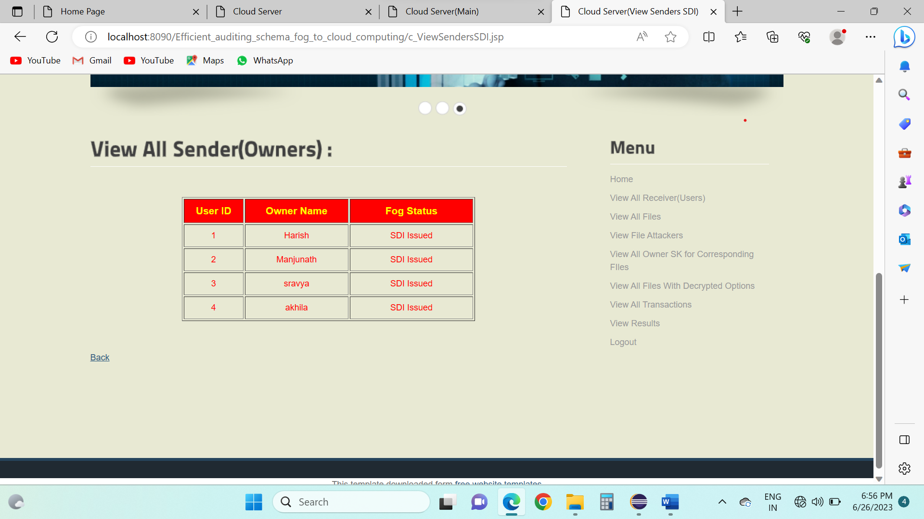

**CONCLUSION:**

The successful demonstration of a compact reconfigurable loop antenna for mobile applications. The small volume of the suggested antenna is 55 5 3 mm3.

It is made up of an RF switch, two tuning branches, and a folded loop structure. One resonating mode for the low band and four resonant phases for the higher band may be produced by the loop structure alone. This work employs two tuning forks to gently tune the high band, and an RF switch to increase the bottom band's working frequency with four states. The suggested antenna may transition between the four modes to cover the frequencies 780-990 MHz and 1680-2740 MHz. At low band, the average efficiency is over 50%, while at high band, it is 52%. The computed SAR value is significantly lower than the 1-g head tissue's 1.6 W/kg value. This recommended antenna is a strong choice for slim mobile devices due to its ideal antenna characteristics and small size.

**REFERENCE:**

[1] S. W. Lee, H. S. Jung, and Y. J. Sung, ‘‘A reconfigurable antenna for LTE/WWAN mobile handset applications,’’ IEEE Antennas Wireless Propag. Lett., vol. 14, pp. 48–51, Jan. 2015.

[2] S. W. Lee and Y. Sung, ‘‘Compact frequency reconfigurable antenna for LTE/WWAN mobile handset applications,’’ IEEE Trans. Antennas Propag., vol. 63, no. 10, pp. 4572–4577, Oct. 2015.

[3] Y.-L. Ban, Z. X. Chen, Z. Chen, K. Kang, and J. L.-W. Li, ‘‘Reconfigurable narrow-frame antenna for heptaband WWAN/LTE smartphone applications,’’ IEEE Antennas Wireless Propag. Lett., vol. 13, pp. 1365–1368, Jul. 2014.

[4] Y. Li, Z. Zhang, J. Zheng, Z. Feng, and M. F. Iskander, ‘‘A compact hepta-band loop-inverted F reconfigurable antenna for mobile phone,’’ IEEE Trans. Antennas Propag., vol. 60, no. 1, pp. 389–392, Jan. 2012.

[5] W.-W. Lee and Y.-S. Cho, ‘‘Frequency tunable antenna using coupling patterns for mobile terminals,’’ Electron. Lett., vol. 51, no. 22, pp. 1725–1726, Oct. 2015.

[6] X. Meng, ‘‘Small-size eight-band frequency reconfigurable antenna loading a MEMS switch for mobile handset applications,’’ Int. J. Antennas Propag., vol. 2014, May 2014, Art. no. 143415.

[7] C.-H. Chang, S.-Y. Huang, W.-C. Wei, and P.-J. Ma, ‘‘Small-size adjustable LTE/WWAN coupled-fed loop antenna for mobile handset applications,’’ Microw. Opt. Technol. Lett., vol. 56, no. 11, pp. 2687–2691, Nov. 2014.

[8] Y.-L. Ban, S.-C. Sun, P.-P. Li, J. L.-W. Li, and K. Kang, ‘‘Compact eightband frequency reconfigurable antenna for LTE/WWAN tablet computer applications,’’ IEEE Trans. Antennas Propag., vol. 62, no. 1, pp. 471–475, Jan. 2014.

[9] K.-L. Wong and C.-H. Huang, ‘‘Printed loop antenna with a perpendicular feed for penta-band mobile phone application,’’ IEEE Trans. Antennas Propag., vol. 56, no. 7, pp. 2138–2141, Jul. 2008.

[10] K.-L. Wong and M.-T. Chen, ‘‘Small-size LTE/WWAN printed loop antenna with an inductively coupled branch strip for bandwidth enhancement in the tablet computer,’’ IEEE Trans. Antennas Propag., vol. 61, no. 12, pp. 6144–6151, Dec. 2013.

[11] M. Zheng, H. Wang, and Y. Hao, ‘‘Internal hexa-band folded monopole/dipole/loop antenna with four resonances for mobile device,’’ IEEE Trans. Antennas Propag., vol. 60, no. 6, pp. 2880–2885, Jun. 2012.

[12] D. Wu, S. W. Cheung, and T. I. Yuk, ‘‘A compact and lowprofile loop antenna with multiband operation for ultra-thin smartphones,’’ IEEE Trans. Antennas Propag., vol. 63, no. 6, pp. 2745–2750, Jun. 2015.

[13] H. Xu et al., ‘‘A compact and low profile loop antenna with six resonant modes for LTE smartphone,’’ IEEE Trans. Antennas Propag., to be published.